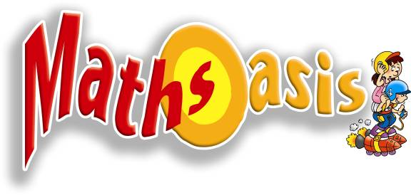
MATHS OASIS PTE LTD
110 Middle Road, #03-03B,
Chiat Hong Building, S(188968)
Reg. No. 200313361G
Tel: 6337-7857 Fax: 6337-3289
www.mathsoasis.com

PSLE MATHS & SCIENCE EVALUATION TEST
Is your child well-prepared for the challenge of PSLE Maths & Science?
Take a 3-hour through Maths & Science evaluation test to find out.

The Evaluation aims to help your child identify
- Their strengths and weakness.
- Misconceptions about certain concepts in Maths & Science that is
hindering their progress.
- Skills acquired and areas for improvement.

Administrative details of the Maths & Science Evaluation Test
Date: 8 Aug 2007(Wed) or 10 Aug 2007 (Fri)
Time: 2 p.m – 5p.m
Venue: Maths Oasis Pte Ltd: 110 Middle Road #03-03B Chiat Hong Bldg S(188968).
Contact: 6337-7857, HP: 9187-9006.
Fee: S$70 (Save $5 if you attend the evaluation test conducted on these two days.Usual fee: $75).
The evaluation also comes with a report highlighting your child’s strengths & weaknesses with respect to the topics and skills requirement for the forthcoming PSLE exams.

With a better understanding of your child’s misconceptions, the topics and skills that need attention, you can help your child plan his/her revision more effectively.

Registration Hotline: 6337-7857. Email: cs@mathsoasis.com

Registration Form

Please register me for: 8 August 2007 (Wed) 10 August 2007 (Fri)*

Student’s Name: ____________________________ School: _______________ Level: _____

Date of Birth: _____/______/__________(dd/mm/yy)

Parent’s Name: _______________________ Tel:(H) ____________ (HP)_______________

Email: _______________________________________ Current Student/New Student

Payment:  Cash  Cheque(_________________ made payable to Maths Oasis Pte Ltd)
You may mail your completed registration form with cheque payment to Maths Oasis Pte Ltd by 6 August 2007.
*Pls delete whichever is inapplicable.
Mentorship Programme for PSLE students: 1-to-1 coaching by student mentors is also available. Lessons will be tailored to meet the needs of the individual.

